Q1)

Creating first internet access security group

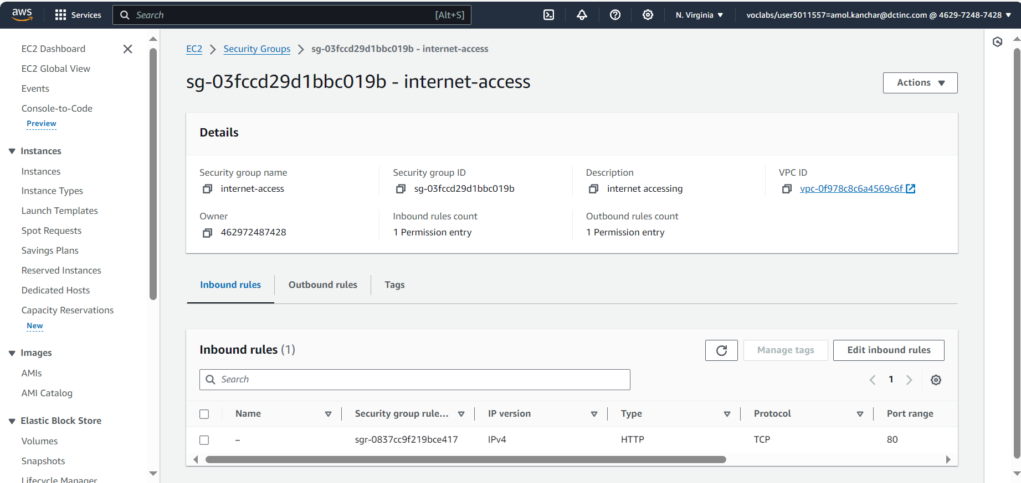

Creating second developers security group for connecting with SSH and in source I give MYIP

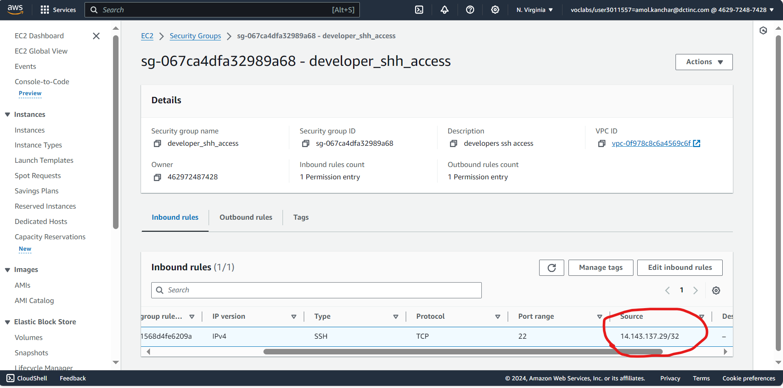

1. Creating Instance with above security group

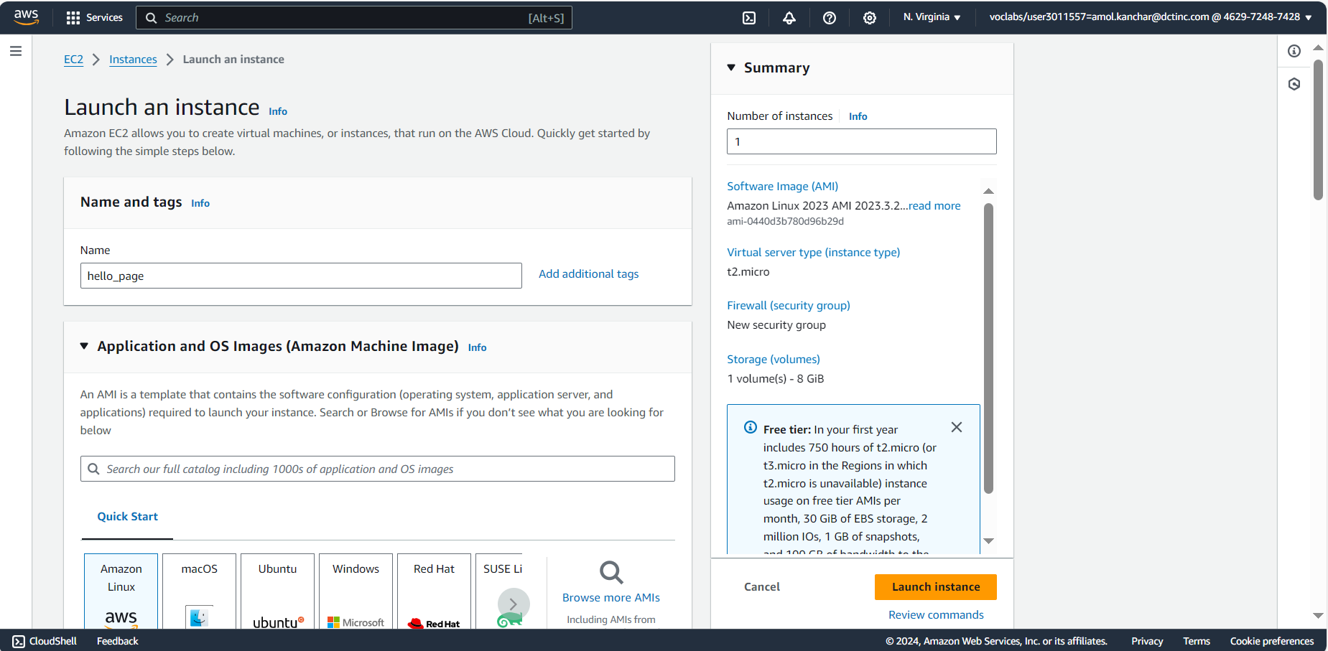

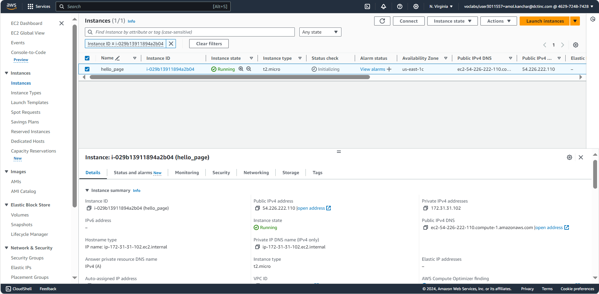

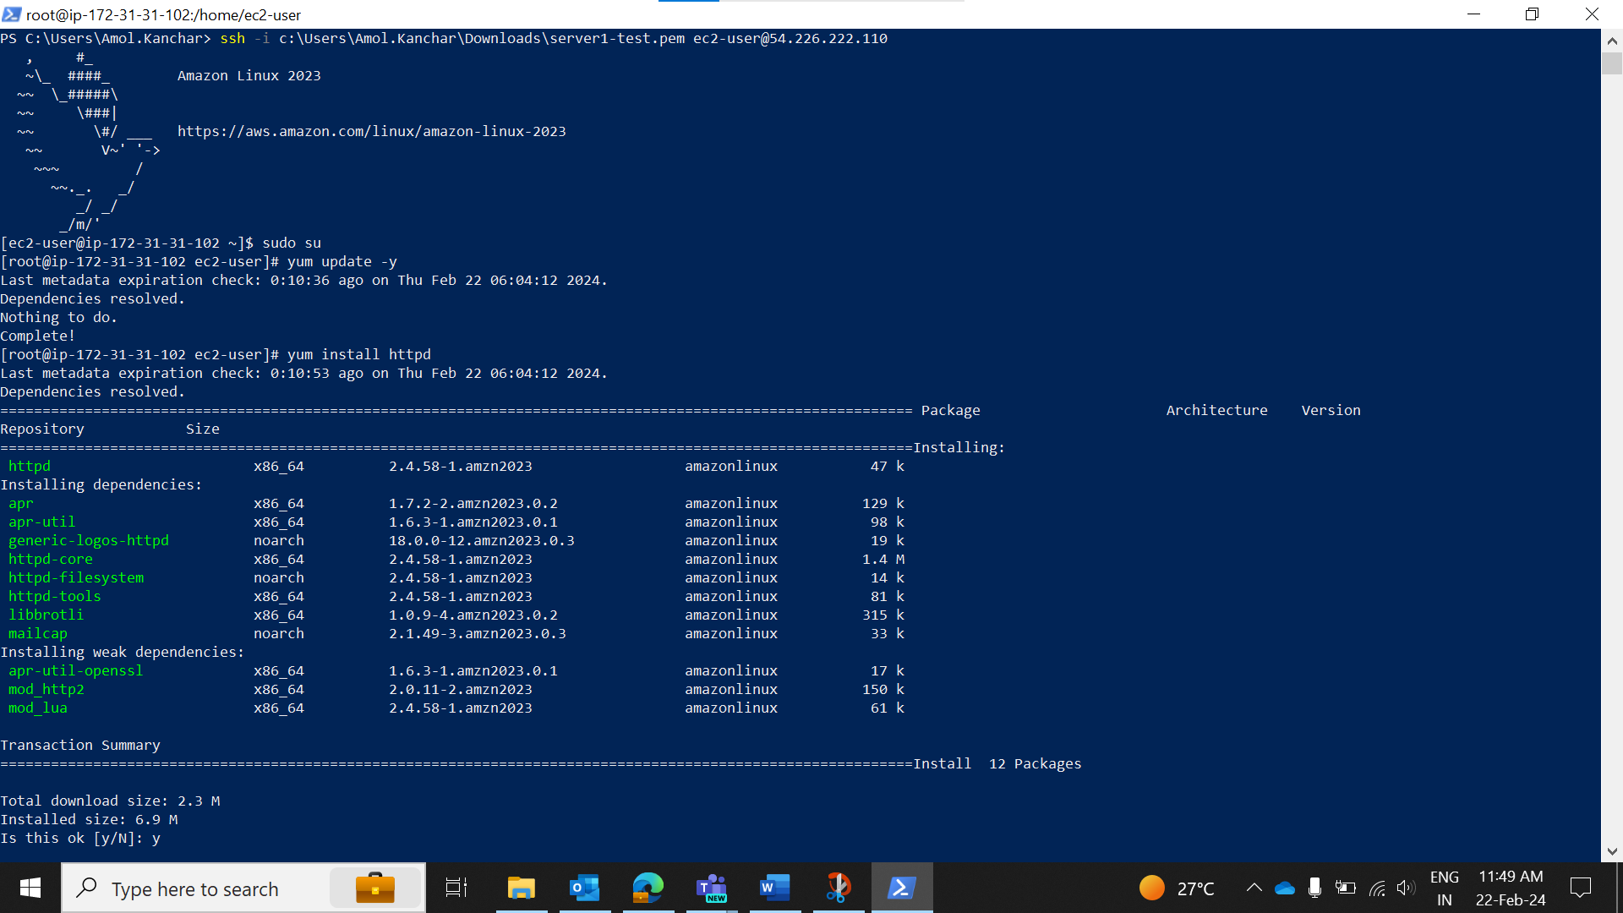

Opening web page with Public-IP

1. Creating target group before load balancer to allocate EC2 as a target

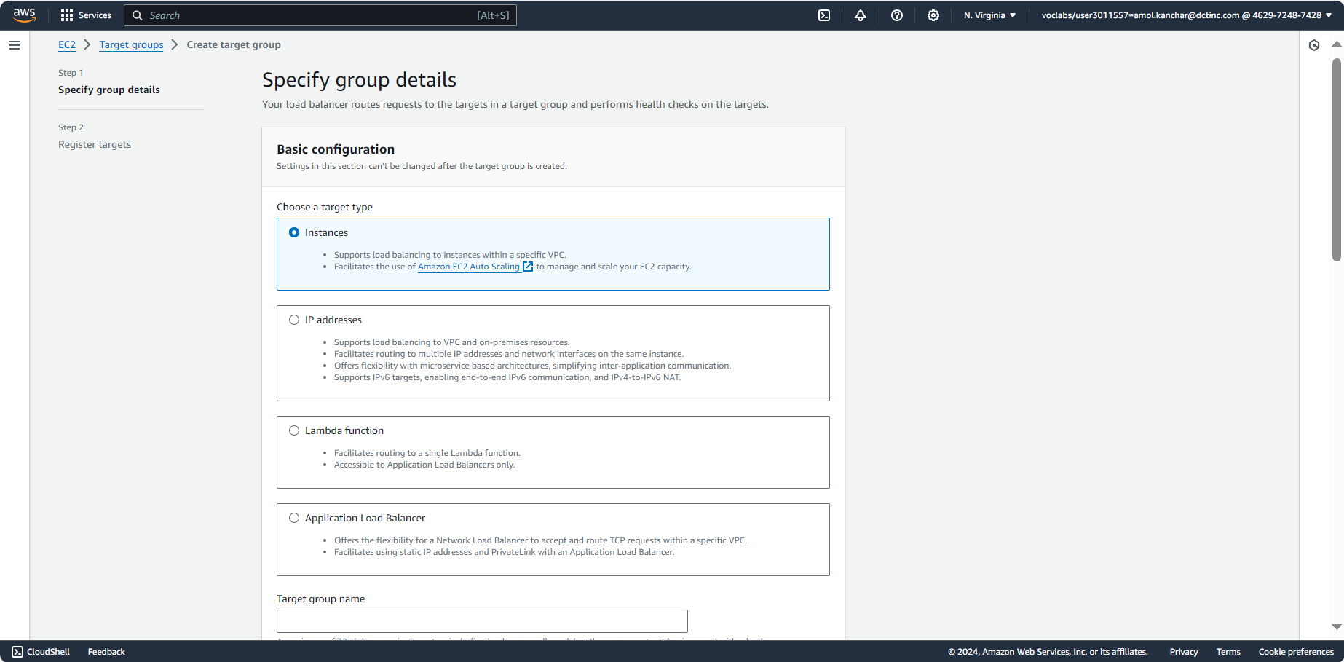

Creating application load balancer

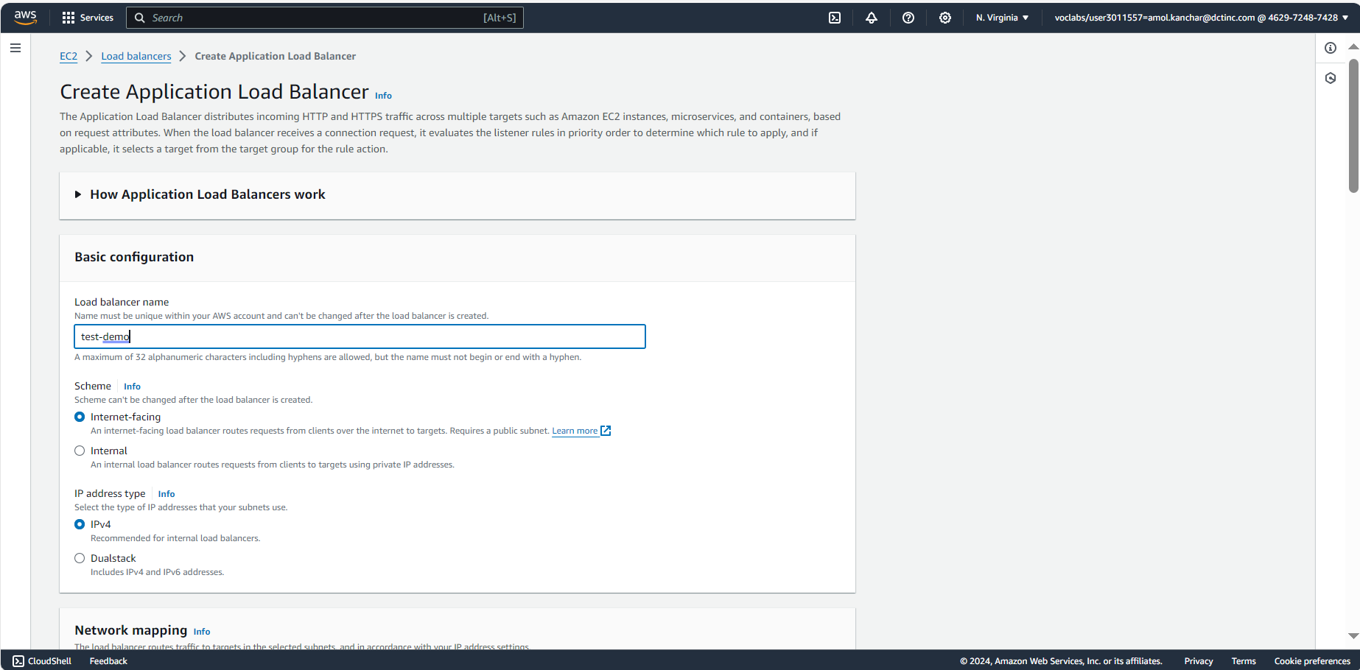

Adding security group internet access http

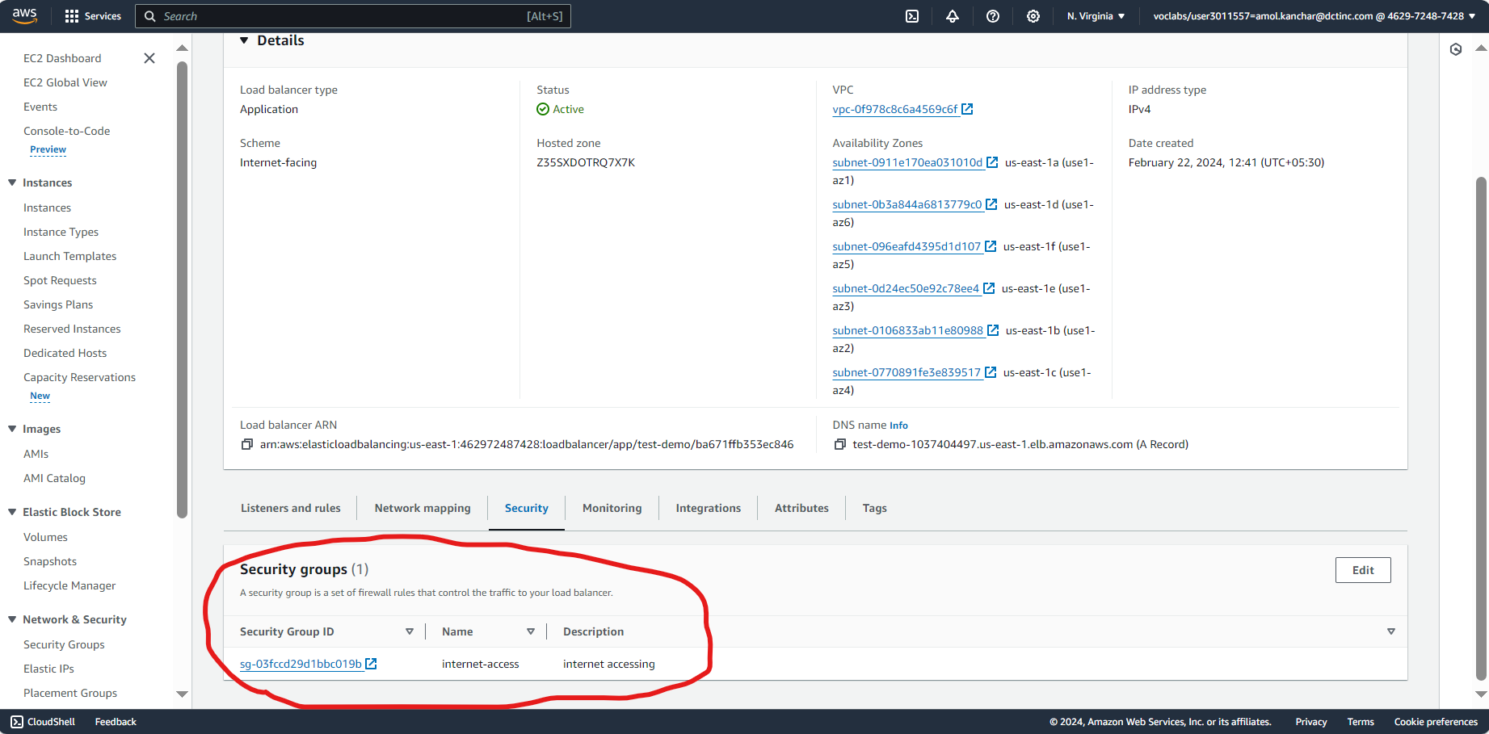

Creating second ec2 web page hello guys with same steps above and adding to it in target group

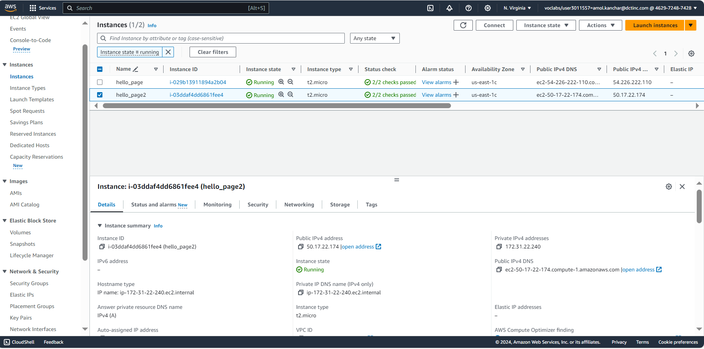

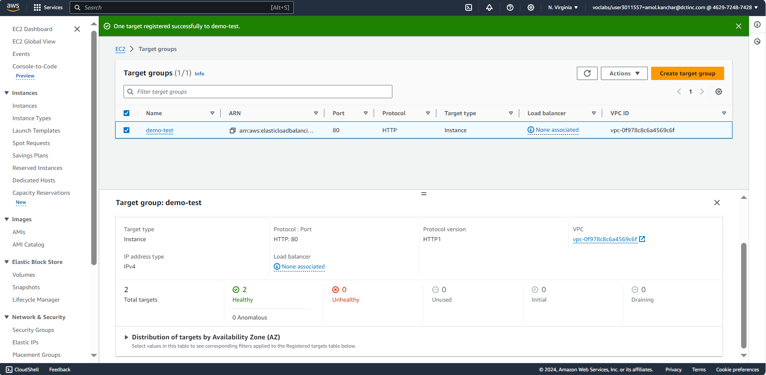

1. Creating AUTO scaling Group

Creating image

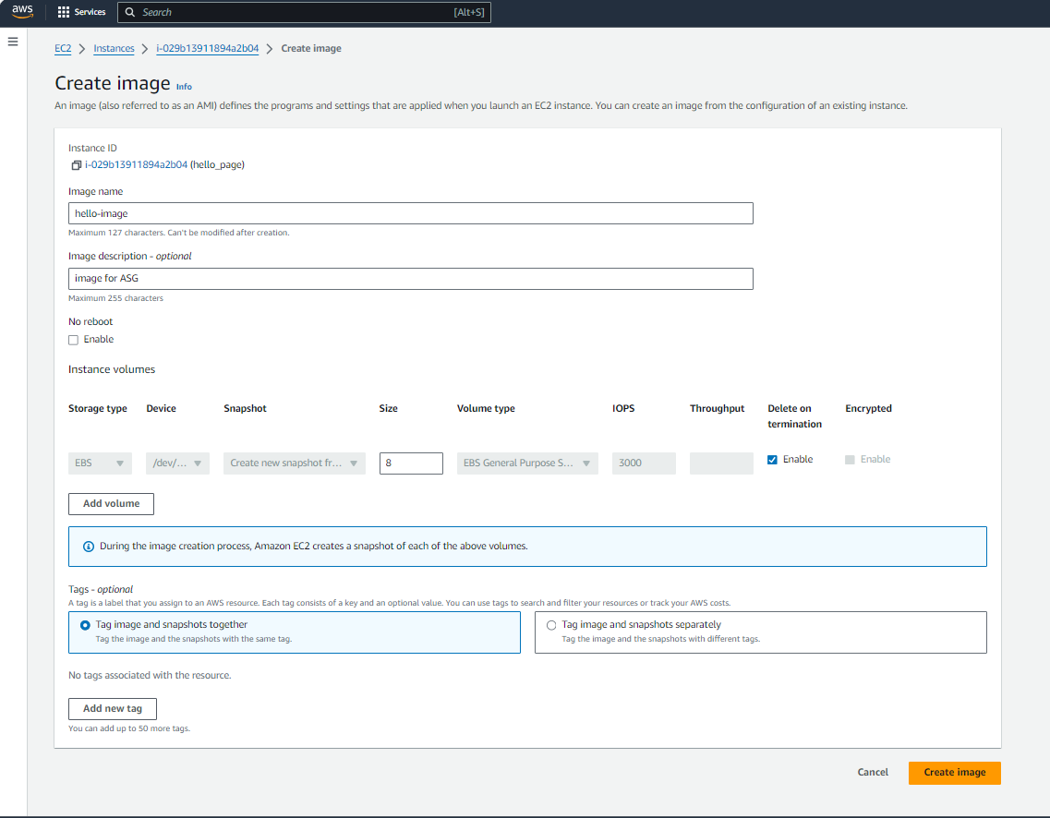

Creating Template for ASG

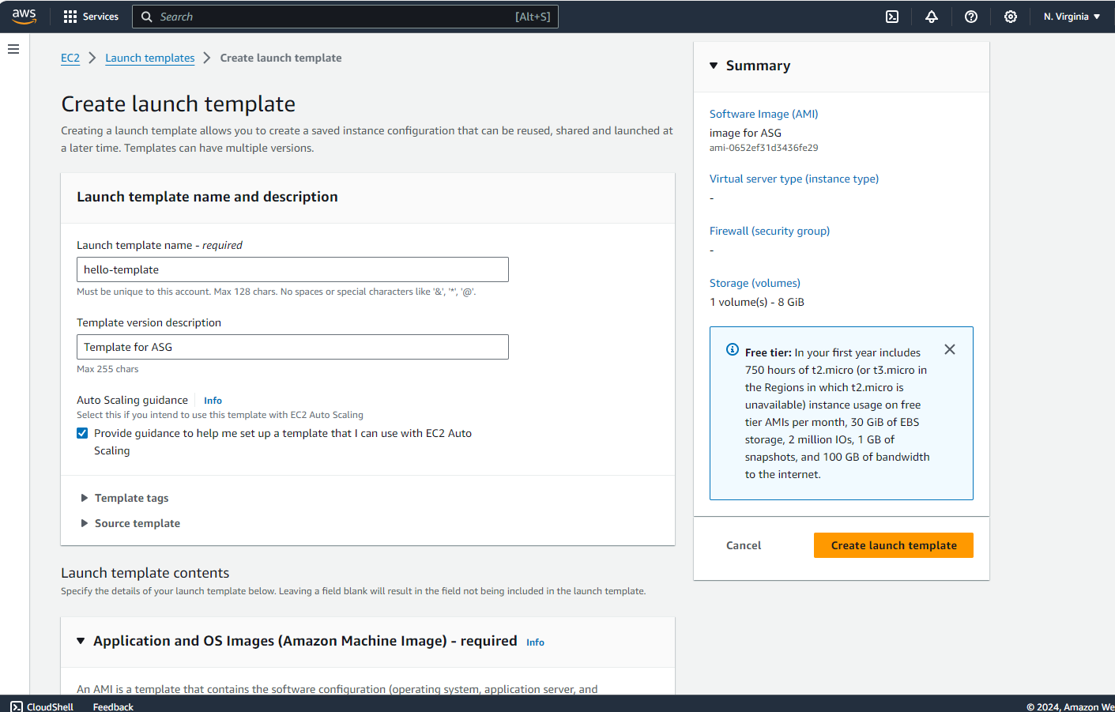

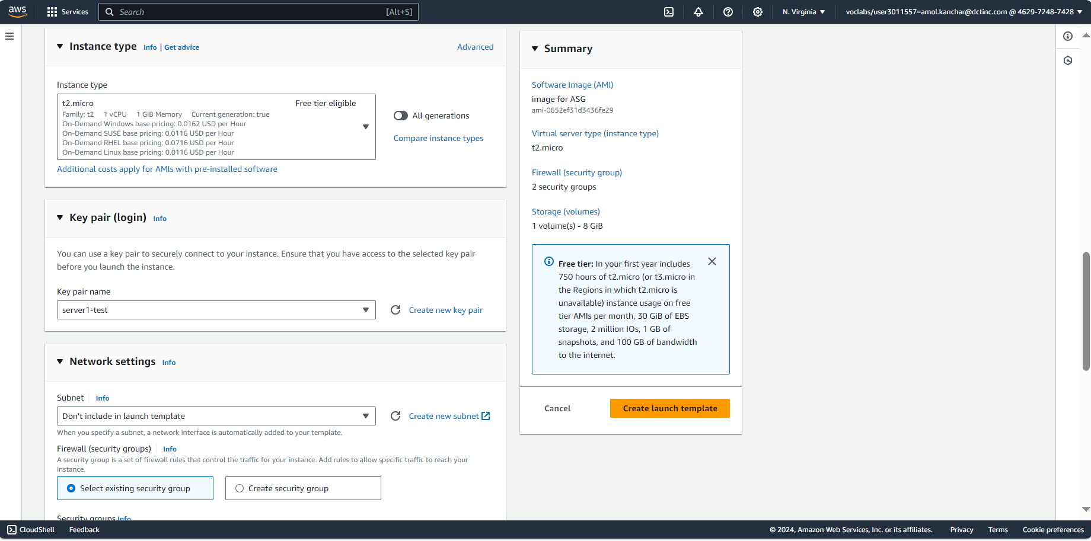

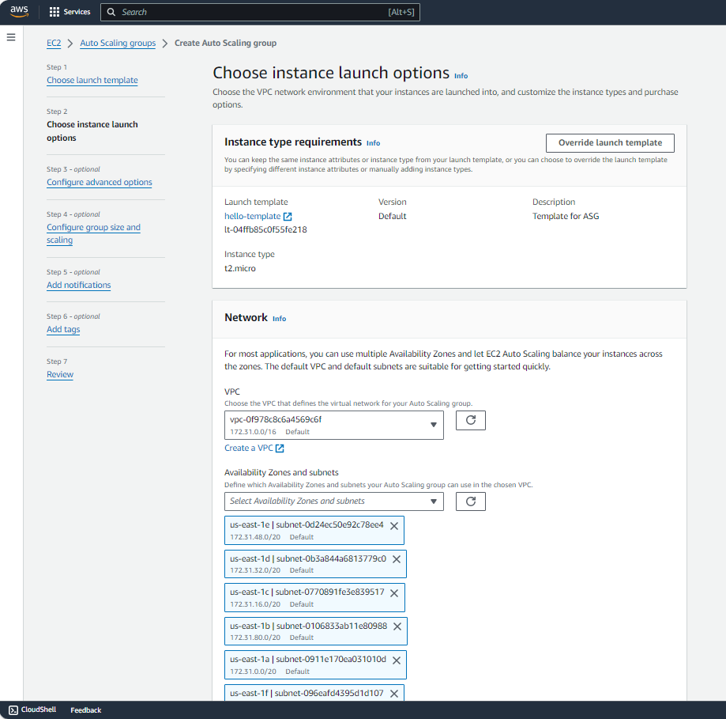

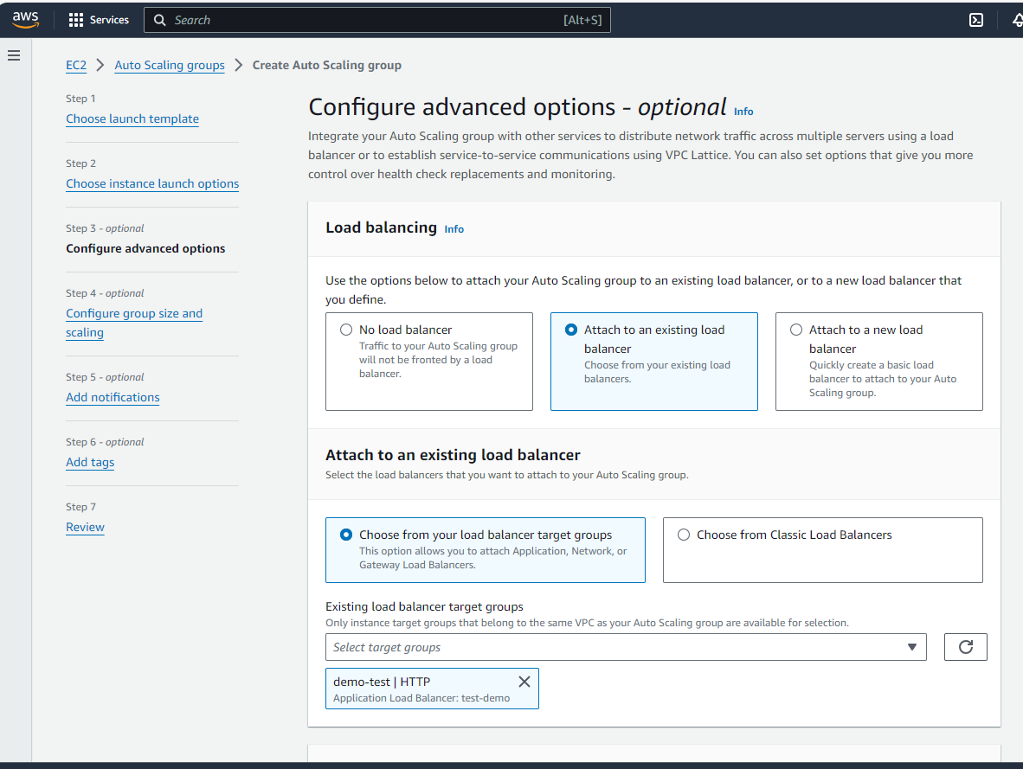

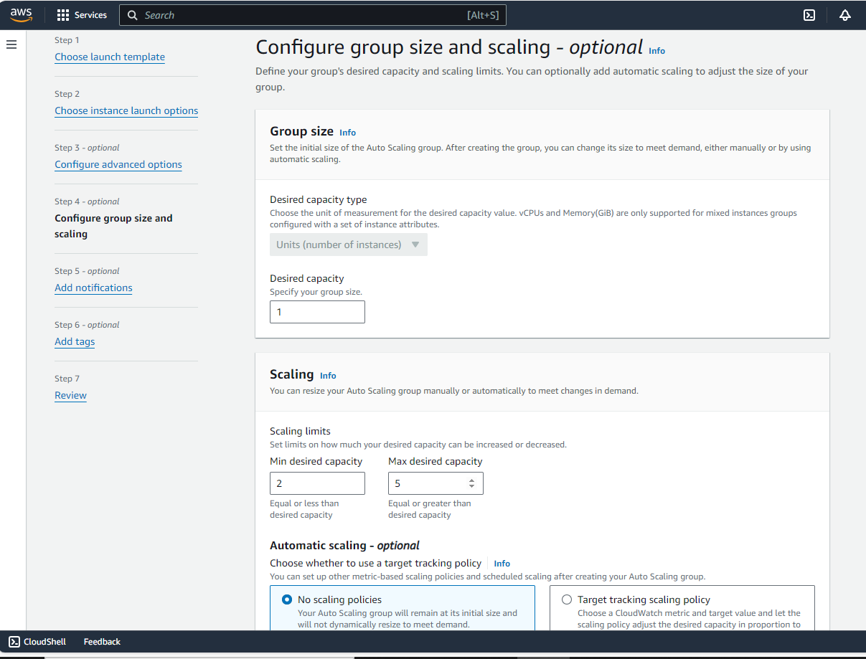

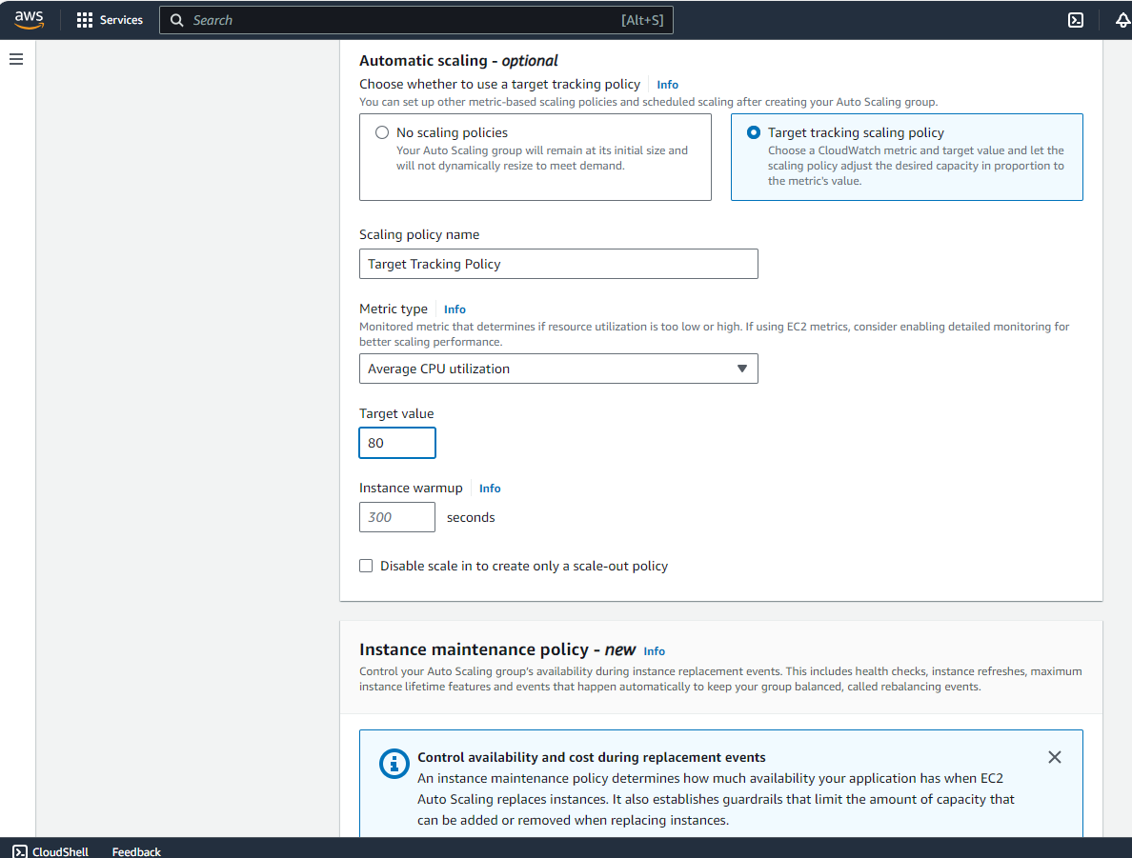

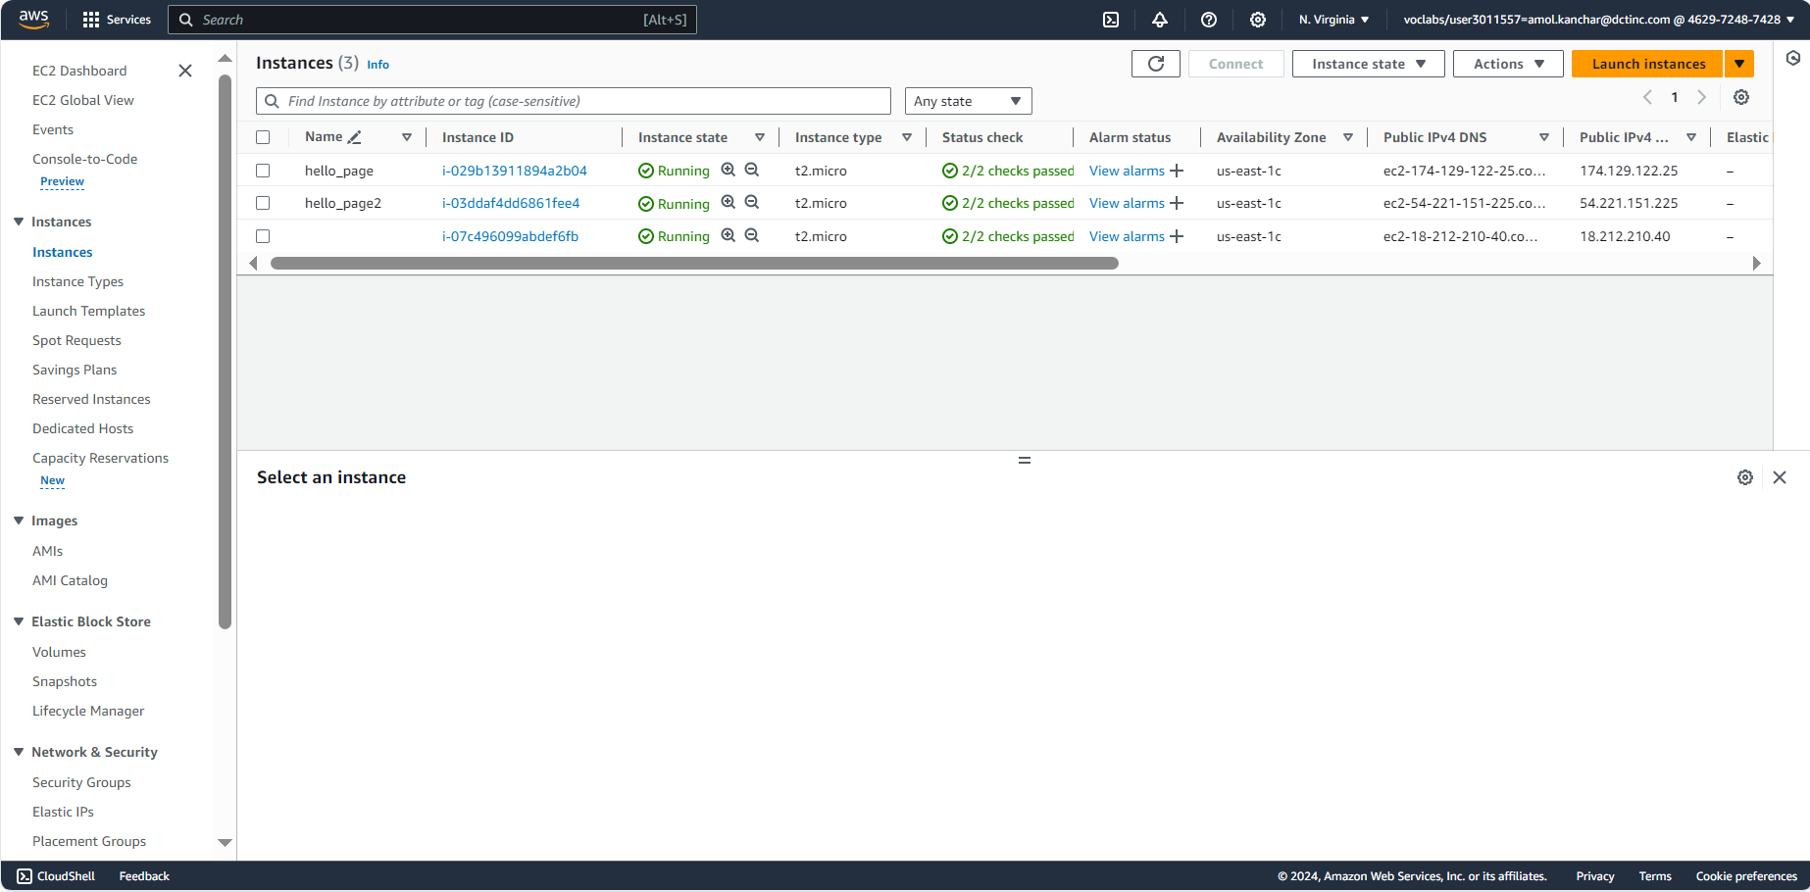

Q2) Static Website Hosting



